**PL/SQL**

**Table Structure:**

1. **Customers**

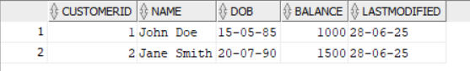

1. **Accounts**

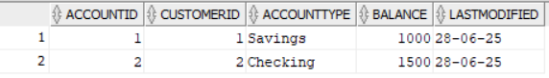

1. **Transactions**

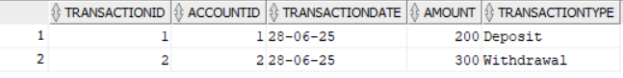

1. **Loans**



1. **Employees**

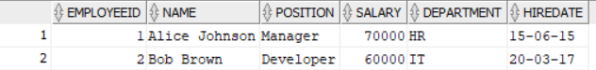

**Exercise 1: Control Structures**

**Scenario 1:** The bank wants to apply a discount to loan interest rates for customers above 60 years old.

* + **Question:** Write a PL/SQL block that loops through all customers, checks their age, and if they are above 60, apply a 1% discount to their current loan interest rates.

**Query:**

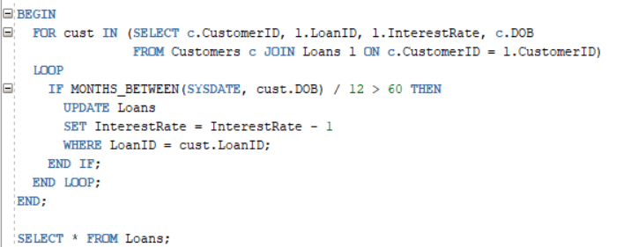

**Scenario 2:** A customer can be promoted to VIP status based on their balance.

* + **Question:** Write a PL/SQL block that iterates through all customers and sets a flag IsVIP to TRUE for those with a balance over $10,000.

**Query:**

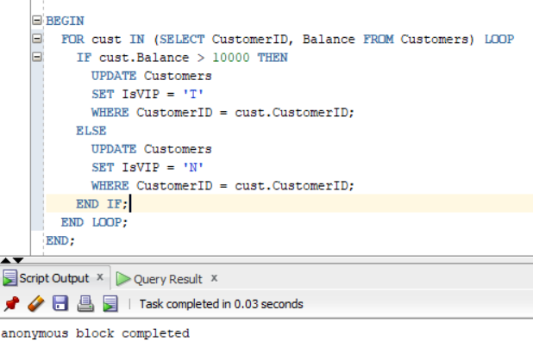

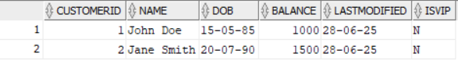

**Scenario 3:** The bank wants to send reminders to customers whose loans are due within the next 30 days.

* + **Question:** Write a PL/SQL block that fetches all loans due in the next 30 days and prints a reminder message for each customer.

**Query:**

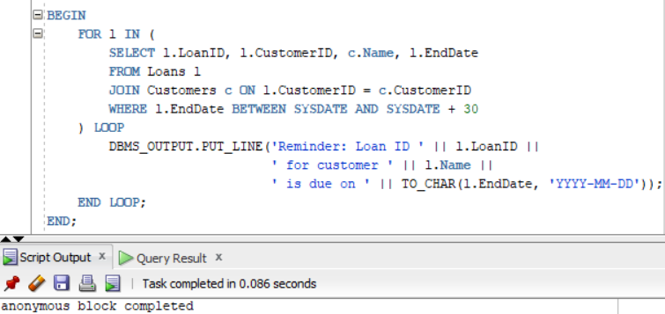

**Exercise 2: Error Handling**

**Scenario 1:** Handle exceptions during fund transfers between accounts.

* + **Question:** Write a stored procedure **SafeTransferFunds** that transfers funds between two accounts. Ensure that if any error occurs (e.g., insufficient funds), an appropriate error message is logged and the transaction is rolled back.

**Query:**

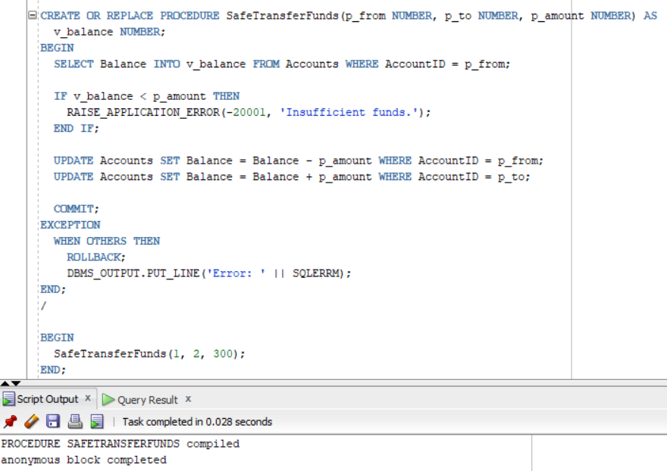

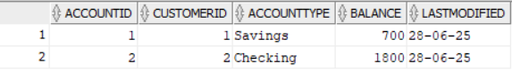

**Scenario 2:** Manage errors when updating employee salaries.

* + **Question:** Write a stored procedure **UpdateSalary** that increases the salary of an employee by a given percentage. If the employee ID does not exist, handle the exception and log an error message.

**Query:**

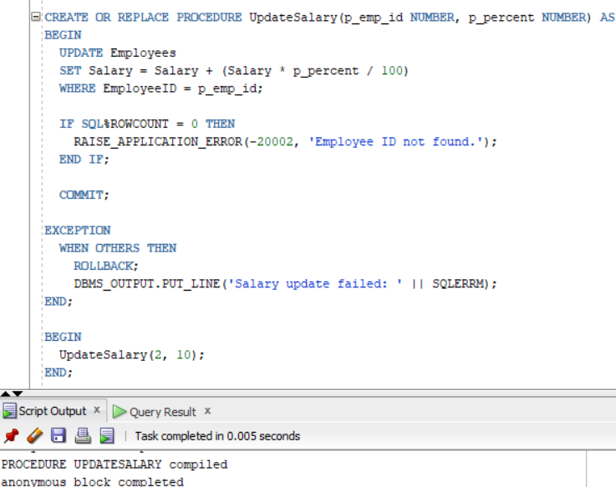

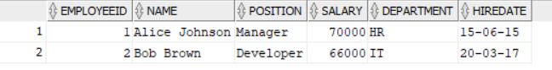

**Scenario 3:** Ensure data integrity when adding a new customer.

* + **Question:** Write a stored procedure **AddNewCustomer** that inserts a new customer into the Customers table. If a customer with the same ID already exists, handle the exception by logging an error and preventing the insertion.

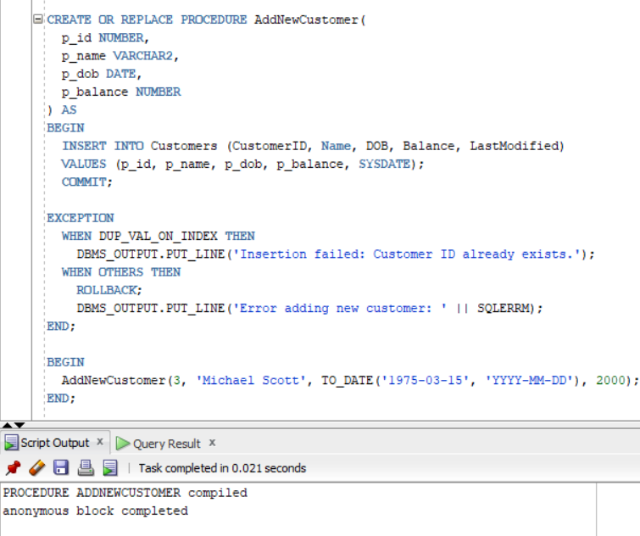

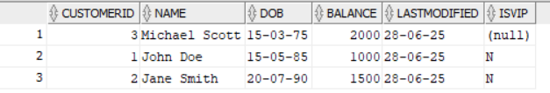

**Exercise 3: Stored Procedures**

**Scenario 1:** The bank needs to process monthly interest for all savings accounts.

* + **Question:** Write a stored procedure **ProcessMonthlyInterest** that calculates and updates the balance of all savings accounts by applying an interest rate of 1% to the current balance.

**Query:**

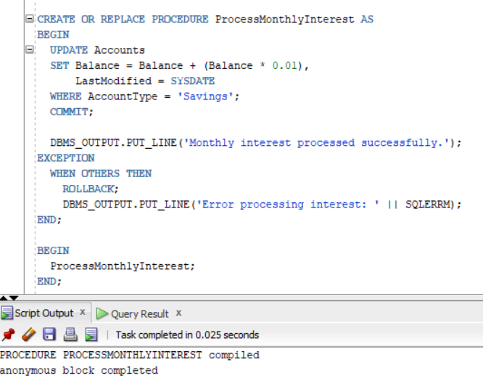

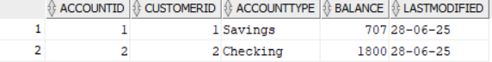

**Scenario 2:** The bank wants to implement a bonus scheme for employees based on their performance.

* + **Question:** Write a stored procedure **UpdateEmployeeBonus** that updates the salary of employees in a given department by adding a bonus percentage passed as a parameter.

**Query:**

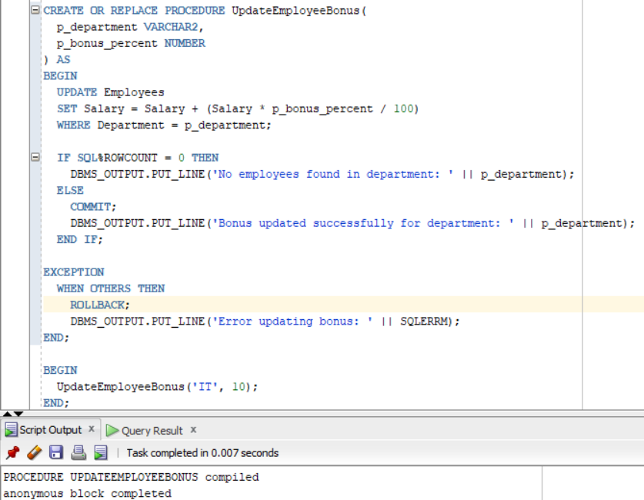

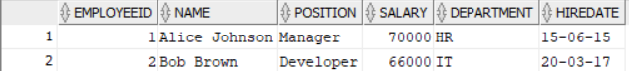

**Scenario 3:** Customers should be able to transfer funds between their accounts.

* + **Question:** Write a stored procedure **TransferFunds** that transfers a specified amount from one account to another, checking that the source account has sufficient balance before making the transfer.

**Query:**

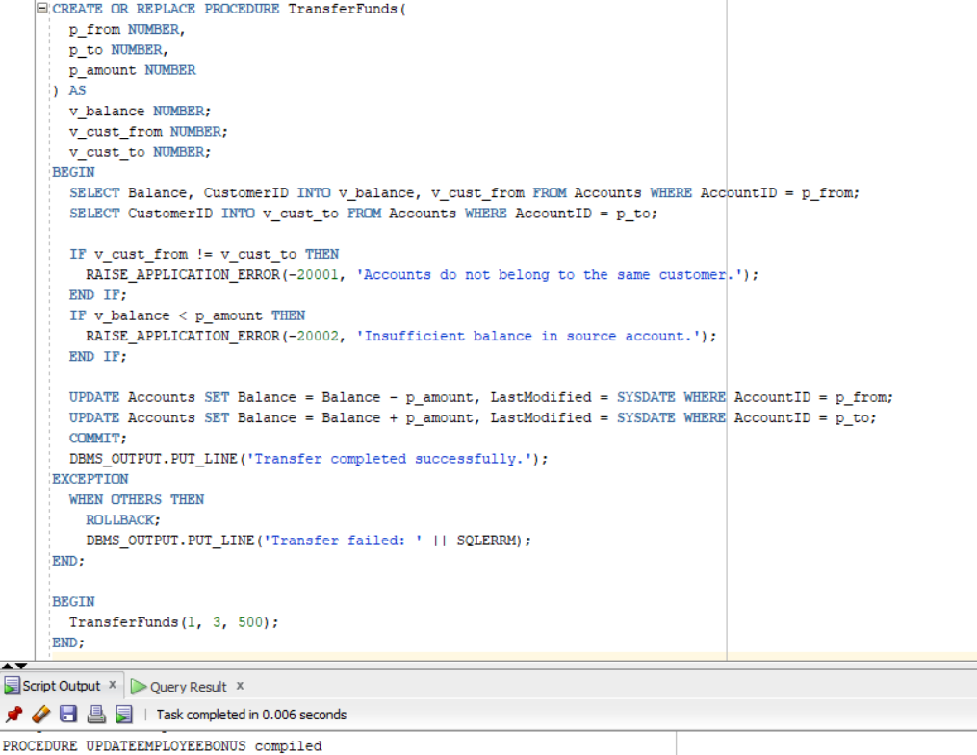

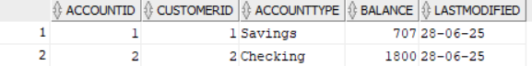

**Exercise 4: Functions**

**Scenario 1:** Calculate the age of customers for eligibility checks.

* + **Question:** Write a function CalculateAge that takes a customer's date of birth as input and returns their age in years.

**Query:**

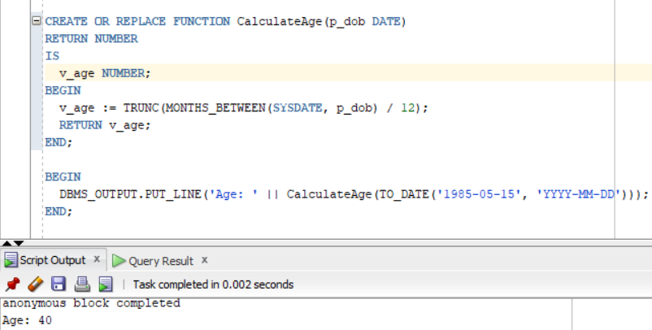

**Scenario 2:** The bank needs to compute the monthly installment for a loan.

* + **Question:** Write a function **CalculateMonthlyInstallment** that takes the loan amount, interest rate, and loan duration in years as input and returns the monthly installment amount.

**Query:**

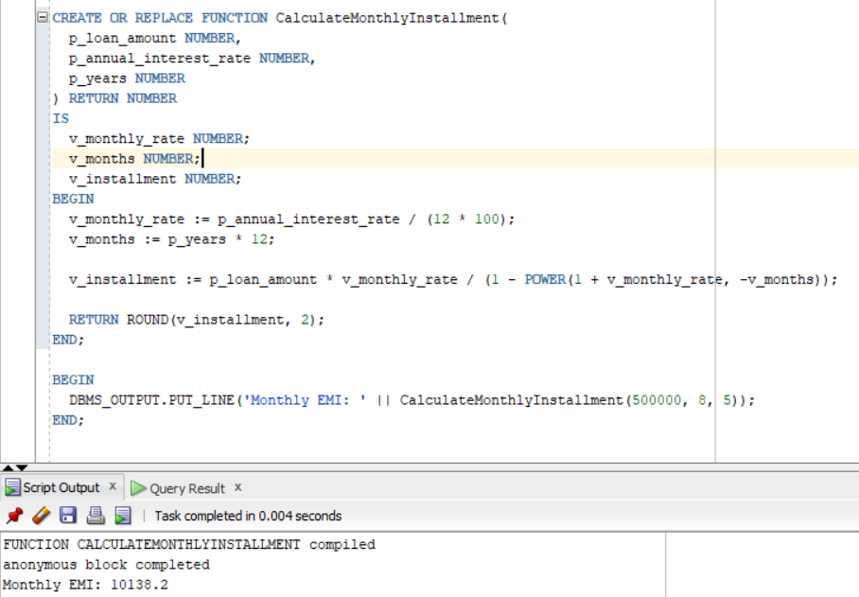

**Scenario 3:** Check if a customer has sufficient balance before making a transaction.

* + **Question:** Write a function **HasSufficientBalance** that takes an account ID and an amount as input and returns a boolean indicating whether the account has at least the specified amount.

**Query:**

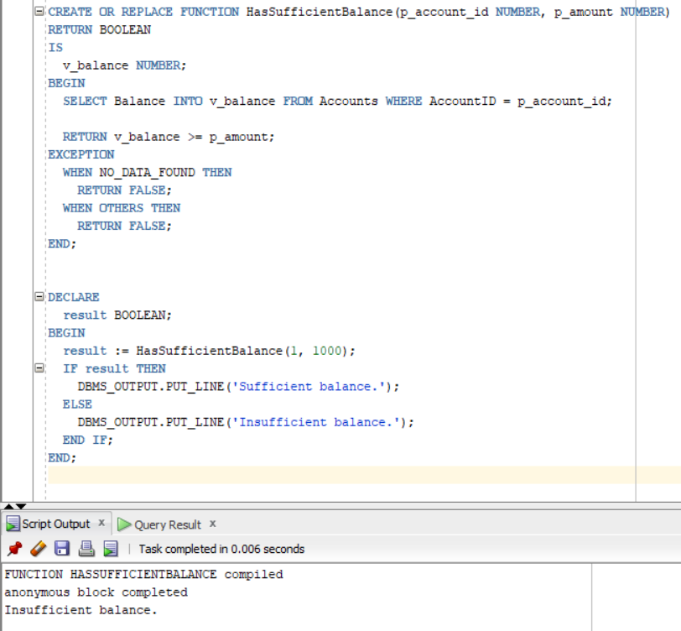

**Exercise 5: Triggers**

**Scenario 1:** Automatically update the last modified date when a customer's record is updated.

* + **Question:** Write a trigger **UpdateCustomerLastModified** that updates the LastModified column of the Customers table to the current date whenever a customer's record is updated.

**Query:**

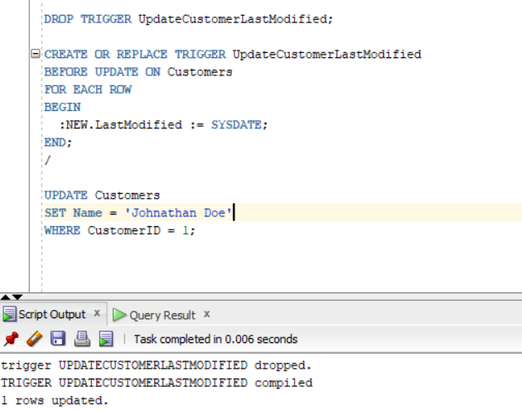

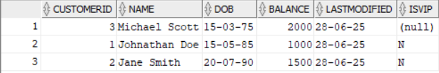

**Scenario 2:** Maintain an audit log for all transactions.

* + **Question:** Write a trigger **LogTransaction** that inserts a record into an AuditLog table whenever a transaction is inserted into the Transactions table.

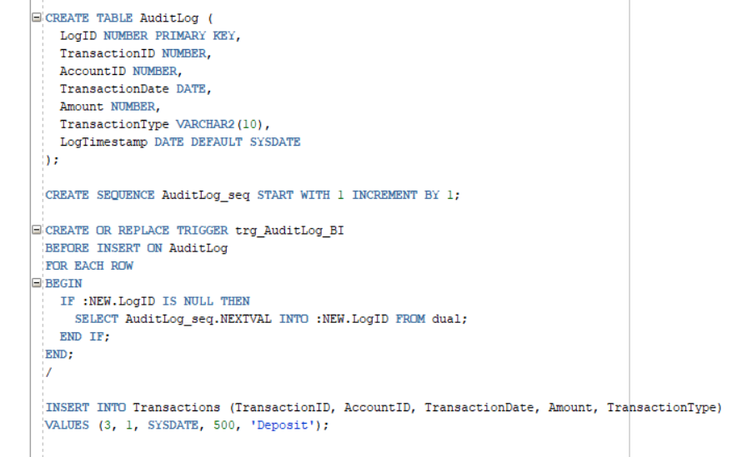

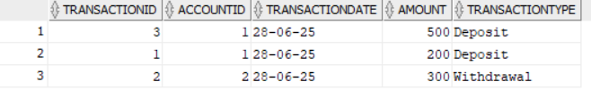

**Scenario 3:** Enforce business rules on deposits and withdrawals.

* + **Question:** Write a trigger **CheckTransactionRules** that ensures withdrawals do not exceed the balance and deposits are positive before inserting a record into the Transactions table.

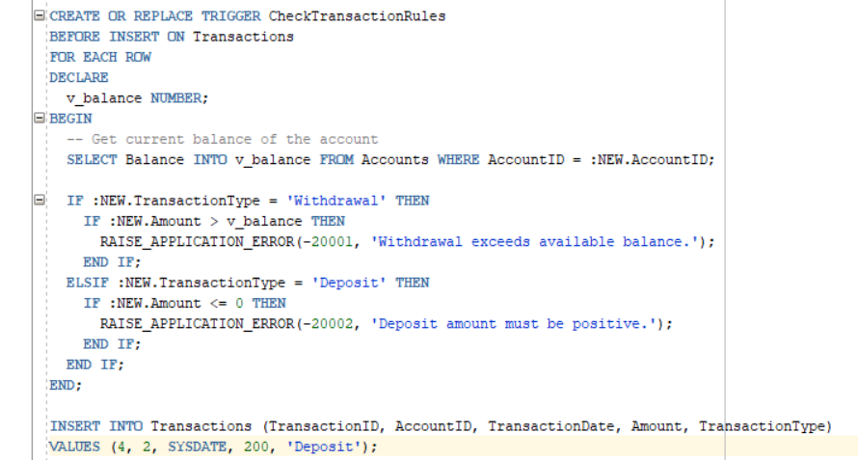

**Exercise 6: Cursors**

**Scenario 1:** Generate monthly statements for all customers.

* + **Question:** Write a PL/SQL block using an explicit cursor **GenerateMonthlyStatements** that retrieves all transactions for the current month and prints a statement for each customer.

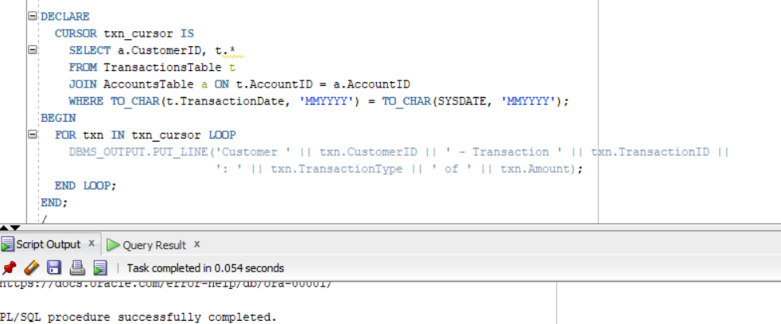

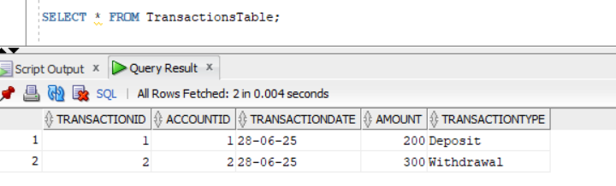

**Scenario 2:** Apply annual fee to all accounts.

* + **Question:** Write a PL/SQL block using an explicit cursor **ApplyAnnualFee** that deducts an annual maintenance fee from the balance of all accounts.

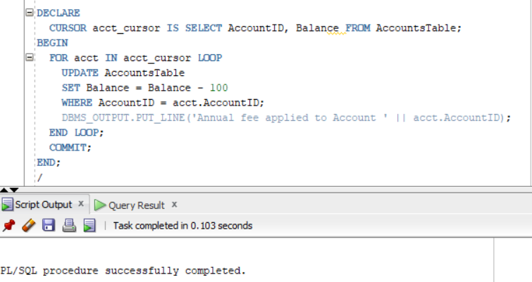

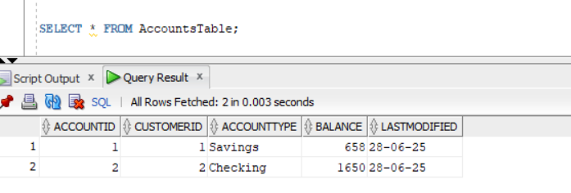

**Scenario 3:** Update the interest rate for all loans based on a new policy.

* + **Question:** Write a PL/SQL block using an explicit cursor **UpdateLoanInterestRates** that fetches all loans and updates their interest rates based on the new policy.

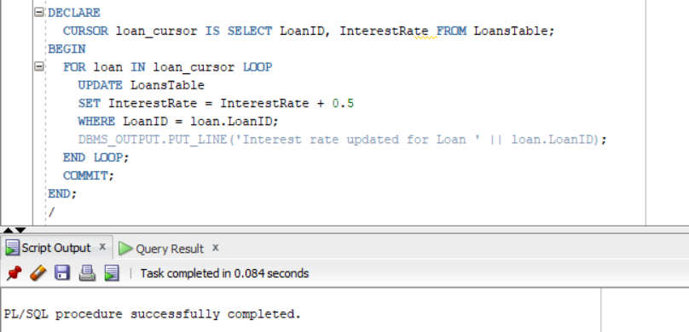

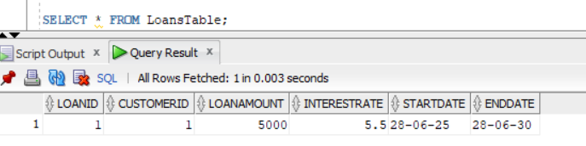

**Exercise 7: Packages**

**Scenario 1:** Group all customer-related procedures and functions into a package.

* + **Question:** Create a package **CustomerManagement** with procedures for adding a new customer, updating customer details, and a function to get customer balance.

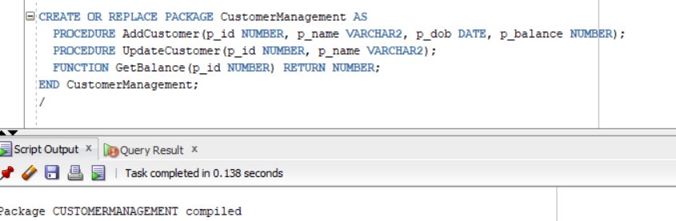

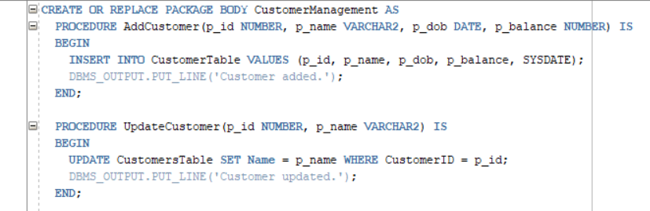

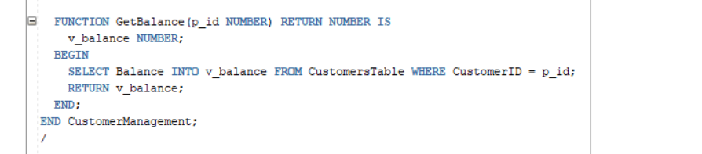

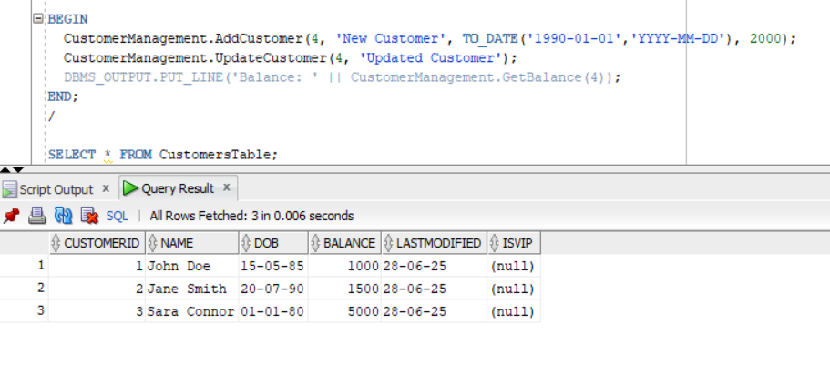

**Scenario 2:** Create a package to manage employee data.

* + **Question:** Write a package **EmployeeManagement** with procedures to hire new employees, update employee details, and a function to calculate annual salary.

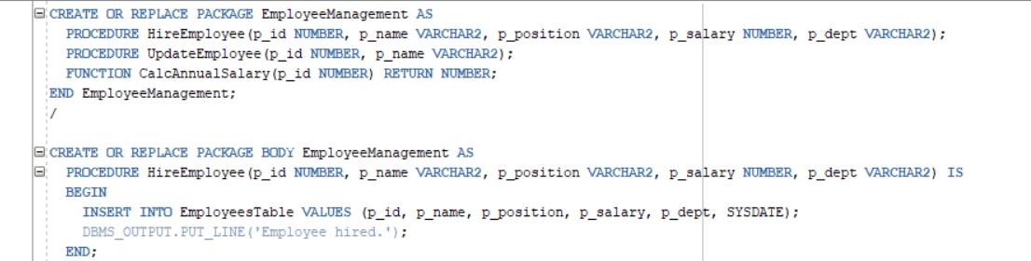

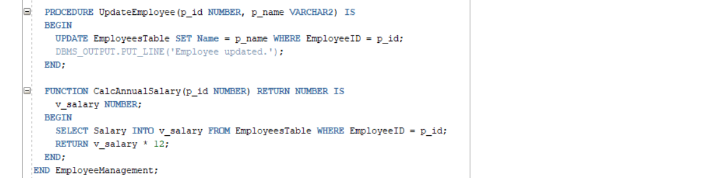

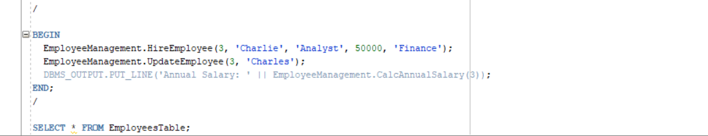

**Scenario 3:** Group all account-related operations into a package.

* + **Question:** Create a package **AccountOperations** with procedures for opening a new account, closing an account, and a function to get the total balance of a customer across all accounts.

